Chapter 19, Solution 38.

From eq. (19.75),
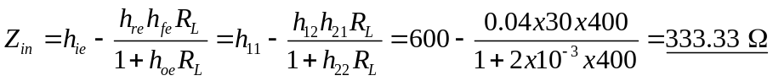
From eq. (19.79),

